**USING RAPTOR – AMSTRONG NUMBER OR NOT**

**T. SUMANTH**

**192011452**

**FLOWCHART**

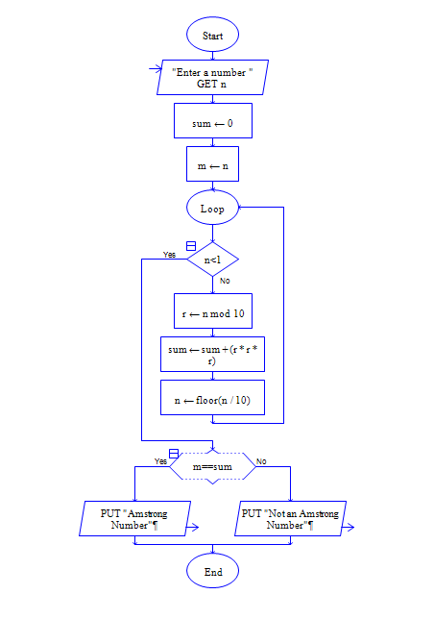

**INPUT**

371

**OUTPUT**

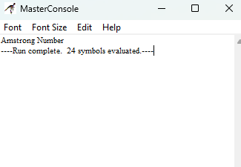

**RESULT:**

The program is executed and verified successfully